**Encoders**

An encoder is a device, circuit, transducer, software program, algorithm or person that converts information from one format or code to another, for the purposes of standardization, speed or compressions.

There is 7 types of encoder:-  
(1) Rotary encoder or Shaft encoder :- An Electro-  
Mechanical device which converts the angular position of   
shaft or axel to an analog or digital code, making it   
angular transducer.  
  
(2) Incremental Encoder :- It is sometimes called a   
relative encoder.  
  
(3) Absolute Position encoder :- These are used to generate   
an electrical signal that indicates absolute mechanical   
position, or an incremental mechanical movement relative to   
a reference position.  
  
(4) Quadrature Encoder :- the most common type of   
incremental encoder uses 2 output channel (A and B) to sense   
position.  
  
(5) Linear Encoder :- it is a sensor, transducer or   
readahead paired with scale that encodes position.  
  
(6) Open Collector Encoder :- the encoder supplied is   
equipped with an npn open collector configuration which if   
wired direct to counter module would require the counter   
module to source current.  
  
(7) Binary Code Encoder : -

**Here is a detailed overview of each of them:**

**Rotary encoder:**

**Overview**

A rotary encoder is a type of position sensor which is used for determining the angular position of a rotating shaft. It generates an electrical signal, either analog or digital, according to the rotational movement.

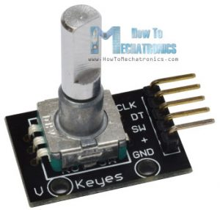

There are many different types of rotary encoders which are classified by either Output Signal or Sensing Technology. The particular rotary encoder that we will use in this tutorial is an incremental rotary encoder and it’s the simplest position sensor to measure rotation.

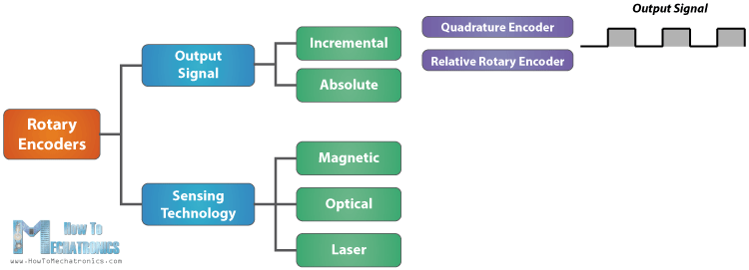

This rotary encoder is also known as quadrature encoder or relative rotary encoder and its output is a series of square wave pulses.

**How Rotary Encoder Works**

Let’s take a closer look at the encoder and see its working principle. Here’s how the square wave pulses are generated: The encoder has a disk with evenly spaced contact zones that are connected to the common pin C and two other separate contact pins A and B, as illustrated below.

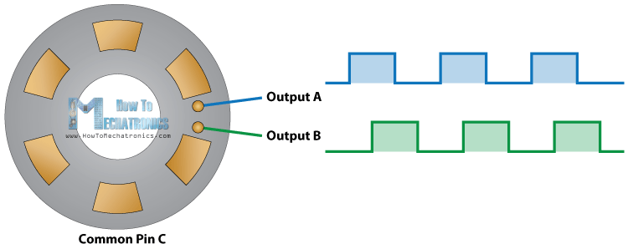

When the disk will start rotating step by step, the pins A and B will start making contact with the common pin and the two square wave output signals will be generated accordingly.

Any of the two outputs can be used for determining the rotated position if we just count the pulses of the signal. However, if we want to determine the rotation direction as well, we need to consider both signals at the same time.

We can notice that the two output signals are displaced at 90 degrees out of phase from each other. If the encoder is rotating clockwise the output A will be ahead of output B.

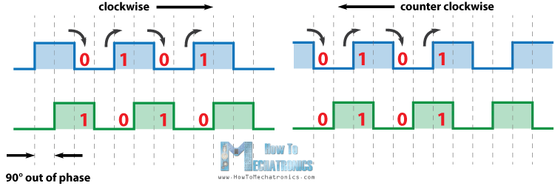

So if we count the steps each time the signal changes, from High to Low or from Low to High, we can notice at that time the two output signals have opposite values. Vice versa, if the encoder is rotating counter clockwise, the output signals have equal values. So considering this, we can easily program our controller to read the encoder position and the rotation direction.

Rotary encoders track motor shaft movement for myriad pieces of industrial equipment and commercial devices. For industrial applications, incremental encoders (used when only relative position is needed, or cost an issue) are typically used with ac induction motors. In contrast, absolute encoders (which give a different binary output at each position, so shaft position is absolutely determined) are often paired with permanent-magnet brushless motors in servo applications. Often, encoder feedback is used to ensure synchronization of the motor stator and rotor positions to drive-supplied current, so current is applied to the windings when the rotor magnets are within a proper position range (to maximize torque.)

**Incremental Encoder:**

An incremental encoder can be used in positioning and motor speed feedback applications which includes servo/light-, industrial- or heavy-duty applications.

An incremental encoder provides excellent speed and distance feedback and, since there are few sensors involved, the systems are both simple and inexpensive. An incremental encoder is limited by only providing change information, so the encoder requires a reference device to calculate motion.

How an Incremental Encoder Works

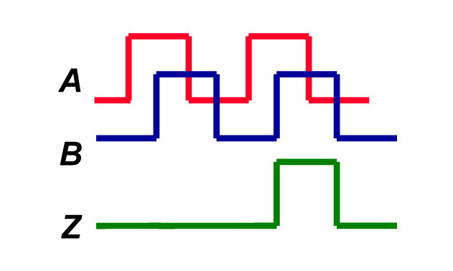An **incremental encoder** provides a specified amount of pulses in one rotation of the encoder. The output can be a single line of pulses (an “A” channel) or two lines of pulses (an “A” and “B” channel) that are offset in order to determine rotation. This phasing between the two signals is called quadrature.

The typical assembly of an **incremental encoder** consists of a spindle assembly, PCB, and cover. The PCB contains a sensor array that creates just two primary signals for the purpose of position and speed.

Optionally, additional signals can be provided:

An index or ‘Z’ channel can be provided as one pulse per revolution signal for homing and pulse count verification on the A and/or B channels. This index can be gated to either A or B in their various states. It can also be un-gated and vary in width.

Commutation (U, V, W) channels can also be provided on some encoders. These signals are aligned to the commutation windings found on servo motors. They also ensure that the drive or amplifier for those motors apply current to each winding in the correct sequence and at the correct level.

Incremental Encoder Alternatives

[Resolvers](http://www.dynapar.com/Products_and_Solutions/Resolvers/)  
Resolvers are electro-mechanical precursors to encoders, based on technology going back to World War II. An electrical current creates a magnetic field along a central winding. There are two windings that are perpendicular to each other. One winding is fixed in place, and the other moves as the object moves. The changes in the strength and location of the two interacting magnetic fields allow the resolver to determine the motion of the object.

The simplicity of the resolver design makes it reliable in even extreme conditions, from cold and hot temperature ranges to radiation exposure, and even mechanical interference from vibration and shock. However, the forgiving nature of resolvers for both origin and application assembly comes at the expense of their ability to work in complex application designs because it cannot produce data with enough accuracy. Unlike **incremental encoders**, resolvers only output analog data, which can require specialized electronics to connect with.

[Absolute Encoder](http://www.dynapar.com/Products_and_Solutions/Rotary-Encoders/Absolute/)

Absolute encoders work in situations where accuracy for both speed and position, fail tolerance, and interoperability matters more than system simplicity. The absolute encoder has the ability to "know where it is" in reference to its position in case of system power-down and restart if the encoder were to move during a power-down.

The absolute encoder itself understands the positioning information – it doesn’t need to rely on outside electronics to provide a baseline index for the encoder position. Especially when compared to resolvers and **incremental encoders**, the obvious strength of absolute encoders is how their positioning accuracy affects the overall application performance, so it is typically the encoder of choice for higher precision applications such as CNC, medical and robotics

Incremental Encoder Applications

 An **Incremental Encoder** is designed to be versatile and customizable to fit a wide variety of applications. The three broad categories of applications based on environment are:

* Heavy Duty: demanding environment with a high probability of contaminants and moisture, higher temperature, shock, and vibration requirements as seen in pulp, paper, steel, and wood mills.
* Industrial Duty: general factory operating  environment which requires standard IP ratings,moderate  shock, vibration, and temperature specs as seen in food and beverage, textile, generally factory automation plants.
* *Light Duty/Servo: controlled environment with high accuracy and temperature requirements such as robotics, electronics, and semiconductors.*

**Absolute Encoders:**

Absolute rotary encoders measure actual position by generating a stream of unique digital codes (instead of pulses) that represent the encoder's actual position. Single turn absolute encoders output codes that are repeated every full revolution and do not output data to indicate how many revolutions have been made. Multi-turn absolute encoders output a unique code for each shaft position through every rotation, up to 4,096 revolutions. Unlike incremental encoders, absolute encoders will retain correct position even if power fails without homing at startup.

Absolute encoders come in two categories, single-turn encoders and multi-turn encoders. These absolute encoders provide a variety of resolutions (i.e. 12, 13, 14, 17 bit). The sizes of these absolute encoders are compact to enable easier integration into space constraint applications including medical, security, brushless DC motors, and industrial applications.

**Quadrature encoder**

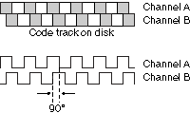

The most common type of incremental encoder uses two output channels (A and B) to sense position. Using two code tracks with sectors positioned 90 degrees out of phase, the two output channels of the quadrature encoder indicate both position and direction of rotation. If A leads B, for example, the disk is rotating in a clockwise direction. If B leads A, then the disk is rotating in a counter-clockwise direction.

By monitoring both the number of pulses and the relative phase of signals A and B, you can track both the position and direction of rotation.

Some quadrature encoders also include a third output channel, called a zero or index or reference signal, which supplies a single pulse per revolution. This single pulse is used for precise determination of a reference position.

**Optical Encoder**

Rotary optical encoders, the most widespread encoder design, consist of an LED light source, light detector, code disc, and signal processor.

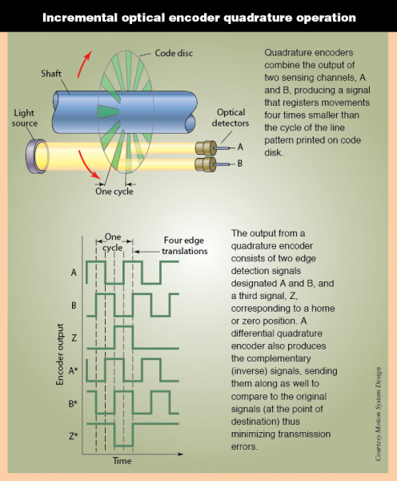**Measurement precision reflects the mechanical precision of the pattern on the code disk, but is not limited to it. The reason is that, in a quadrature encoder, each opaque region or â€œlineâ€ produces not one, but four distinct reference points. Two points correspond to the leading and trailing edges of the line itself; two additional points correspond to the leading and training edges from the perspective of a second detector. This not only provides higher resolution, four times that of the code disc, but also indicates direction based on which detector responds first.**

The disc has opaque and transparent segments and passes between the LED and detector to intermittently interrupt a light beam. The detector tracks the series of light exposures it receives and sends that information to the processor that extracts motion information.

Two rotary optical encoder subtypes exist: Incremental and absolute.

Incremental encoders are named for their output, consisting of the two square waves, each corresponding to an increment of rotation. Typically, the LED directs rays through a convex lens that focuses the light into a parallel beam; the beam passes through a grid diaphragm, which splits it to produce a second beam of light 90° out of phase. Light passes from A and B channels through a disc onto the photovoltaic or photodiode array. The disc rotation creates a light-dark pattern through the clear and opaque disc segments.

This pattern is read and processed by a photodiode array and decoding circuitry; beams A and B are each received by a separate diode and converted into two square-wave signals ... 90° out of phase, commonly known as quadrature output. It’s then fed into a processor that can process the signal to determine the number of pulses, direction, speed, and other information. Incremental encoders can also have a third channel with a single segment slot or reference that is used to zero or home the device. Alternatively, an incremental sine-wave encoder produces quadrature sine waves (sine and cosine) instead of square quadrature. Arctangent functioning yields arbitrary levels of resolution.

An **absolute** encoder has multiple detectors and a disc with multiple, unique tracks. The disc produces Gray code output — named after Bell Labs physicist Frank Gray — a binary numeral system for which (unlike straight binary) successive values differ by one bit. Therefore, maximum possible error (if the encoder stops between transitions) is only 0.5 bit. This information is available even if the encoder temporarily shut down.

Taking absolute tracking further, **multiturn optical encoders** clock movement over multiple revolutions. In geared designs, a primary gear meshes with an encoder shaft that moves a secondary gear, and so on: Each gear is an etched disc for which rotation is tracked by the encoder sensing and electronics; the encoder combines the output of all discs to count the total number of shaft turns.

**Gearless multiturn encoder designs** are also manufactured in both optical and magnetic designs, as detailed in the next section.

As mentioned, resolution — often overspecified — is the number of complete cycles produced on one channel within one revolution of the encoder shaft. Parameters affecting accuracy include the number and accuracy of the patterns or slots on the code disc, and the rigidity and stability of the mechanical assembly.

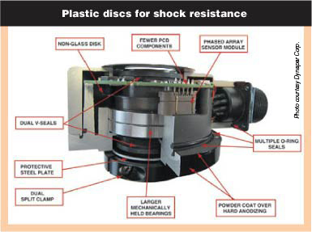This vector-duty encoder sports a hard plastic disc to withstand 400 g shock and larger, well-secured bearings increase resistance to runout. Resolution reaches 5,000 ppr and (unlike plastic-disc encoders of the past) withstands -40Â° to 100Â° C, useful on hot vector-duty motors.

The number of optical disc slots dictates direct-read (native) resolution. Too many lines or slots decrease the light that can pass because the slots are necessarily smaller to fit on the disc. Too many lines (or slots) also increase the possibility that this light will produce fringing effects and crosstalk — which reduces signal strength as the counts increase.

Electric interpolation boosts resolution over that of direct-read. A fairly common method for electronic interpolation is to use a voltage divider circuit to subdivide the raw analog signal into the desired number of interpolation steps. Such interpolations (usually a function integrated into encoder logic and transparent to the motion designer) allow for 20x resolution boosts.

### **Encoder subcomponent variables**

Classic optical encoder LED emitters and detectors are large compared to disc slots, so on these designs, a mask is installed between the detector and disc to increase accuracy by sharpening the edges of light pulses falling on the detectors. The mask also allows adjustment to discs of different resolutions — but increases assembly costs and the chance of interference, plus attenuates light to the detector. Myriad manufacturers sell encoders without masks to allow more space between the disc and detectors, increasing resistance to phase error and edge jitter between channels. Enabling technologies are better LEDs, detectors, and lenses.

The code discs (also called wheels) on rotary optical encoders consist of etched metal, Mylar, emulsion on tempered glass, or chrome on glass. The latter gives superior edge definition, immunity to condensation, and durability, though is susceptible to scratching and fracture under shock. Plastic discs are shock resistant, but some can warp at higher temperatures. Metal discs withstand shock, heat, and chemicals, though can exhibit less accuracy than glass varieties.

Unique threats to optics-based encoders are particulate and liquid contamination. In outdoor and washdown applications, liquid ingress occurs when encoders are directly exposed to hot, pressurized water, coolants, lubricants, and cleaning agents. Ambient temperature variations can also accelerate encoder failure rates. During encoder cool down, pressure differences between the outside environment and housing interior can draw air into the latter. As the encoder’s housing temperature drops, contained humidity condenses inside, collecting dew on code disc, printed circuit boards, and wiring — and heightening odds of failure. Finally, without ruggedized sealing, sand, salt, small wood chips, or dust particles can invade standard encoders, blocking optical processes and degrading performance.

### **Rotary magnetic encoders**

Magnetic encoders are inherently rugged and operate reliably under shock and vibration and high temperature. Magnetic debris ingress can degrade rotary magnetic encoder performance, but other contaminants do not. Therefore, rotary magnetic encoders are often used instead of optical encoders. Passive variable reluctance or magnetized strips on a rotating code rotor, wheel, or band are sensed by either a Hall-effect or magnetoresistive sensor. Motor speed and position accuracy dictate which of the two is better suited for an application.

Rotary magnetic encoders can take the form of small, inexpensive devices used in high-volume applications, such as vehicle antilock braking systems, or sophisticated units demanding motion control tasks, such as industrial automation systems and medical equipment. Available variations are incremental and absolute types; non-contact and bearing versions; and units in which rotating unit and encoder body are effectively separate subcomponents.

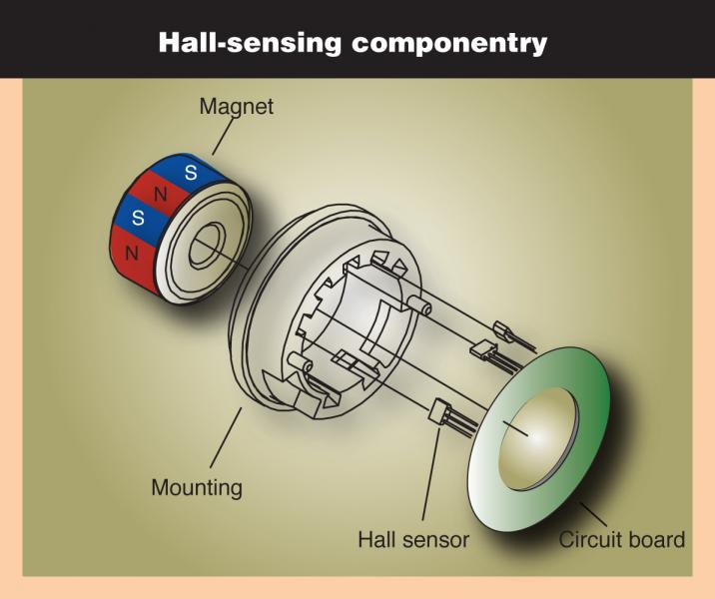In short, most Hall-effect magnetic encoders use a wheel attached to the motor shaft to be tracked, and that wheel is magnetized with north and south poles around its perimeter. It is usually made from an injection-molded ferrite embedded with the pole array.

To illustrate, a 15-mm encoder contains a 7.6-mm-diameter wheel, magnetized with 32 poles (16 north and 16 south) using a static fixture. Fixture size typically limits the number of poles that can be embedded. The pole pitch for a 32-pole motor is about 0.75 mm, the smallest practical size a fixture can handle.

Consider a common setup using a target magnet disc plus three digital Hall-effect sensors (120° electrical apart) on a circuit that pick up commutation signals from the wheel. The Hall effect sensors turn switch when north and south poles pass.

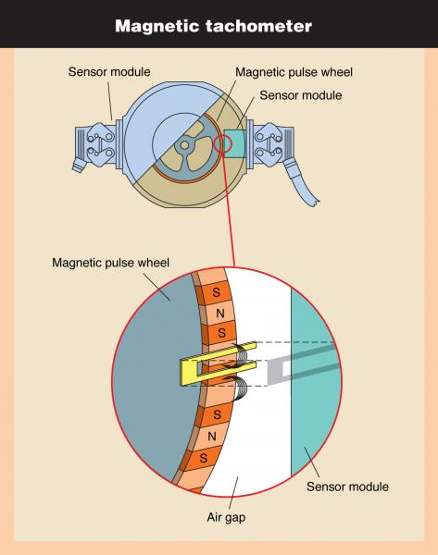Shown here is a bearingless, magnetoresistive-based tachometer with a magnetic pulse wheel that shares many characteristics with the encoders based on this technology as well. The main difference: Unlike encoders, which track position, tachometers only measure speed.

Hall-effect encoders usually switch with an output characterized by hysteresis — when the magnetic field from the rotating encoder wheel reaches a flux density sufficient to overcome a critical threshold level. Likewise, when the detected field reaches a flux density below a lower threshold level, it switches back to the previous state. Consequently, Hall sensors containing 32-pole encoder wheels generate 16 pulses per revolution.

It’s not only commonly sized encoders leveraging this type of operation. Some miniature single-magnet system-on-chip designs integrate field-sensing Hall elements and digital signal processing for simultaneous absolute, incremental, and pulse-width-modulated digital outputs. A small, diametrically polarized magnet rotates above an ASIC; the latter contains an array of Hall effect sensors that detects magnetic flux changes and generates a voltage as the magnet rotates above it.

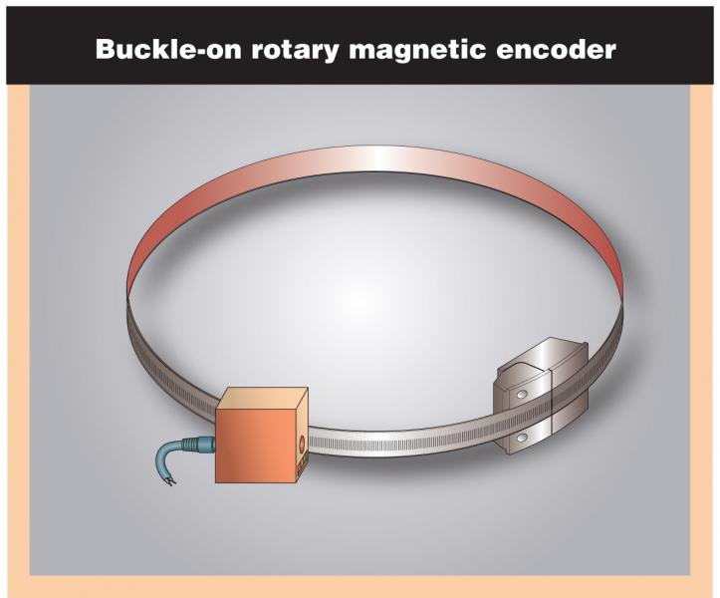Rotary magnetic encoders allow for unique setups. Shown here is a design in which the magnetic rotor and belts, couplings, and connections of traditional designs are eliminated by one flexible, buckle-on flexible strip of magnetic tape. Such designs are suitable on large-shaft motors.

Today, however, higher resolution is needed from miniature and high-end encoders — a need increasingly met by encoders using magnetoresistive material that lowers bulk resistance by about 1.6% in the presence of a saturating magnetic field. Magnetoresistive sensors differ from Hall-effect sensors in two important ways. First, the saturating field is in the range of 0.003 to 0.005 T, an order of magnitude smaller than typical switching fields for digital Hall sensors. This makes magnetoresistors more sensitive measuring devices. Second, the change in resistance is independent of magnetic field polarity, so the 32-pole wheel generates 32 pulses per revolution, twice the resolution of previous sensors.

A magnetoresistive sensor assembly comprises an array of thin nickel-iron permalloy strips.

Strip width is much larger than thickness. The sensor is located above the magnetic track of the encoder wheel with the strips parallel to the wheel axis.

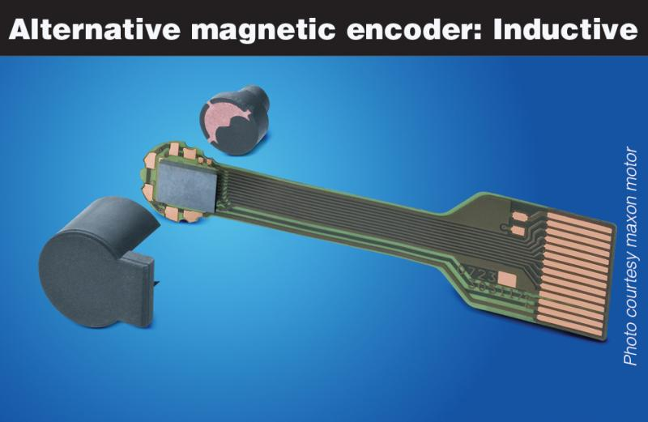Though we focus on Hall-effect and magnetoresistive types, inductive encoders are the third most common rotary magnetic encoder type. They operate by tracking reactionary current-flow resistance (to nearby material) in one or more coils. Soft iron or ferrite sensitivity to high temperatures can be problematic. External magnetic fields can also push their material's permeability to well below the saturation point. One alternative is ironless inductive encoders as the one here: Eddy currents generate contrast to deliver 64 pulses at up to 120,000 rpm.

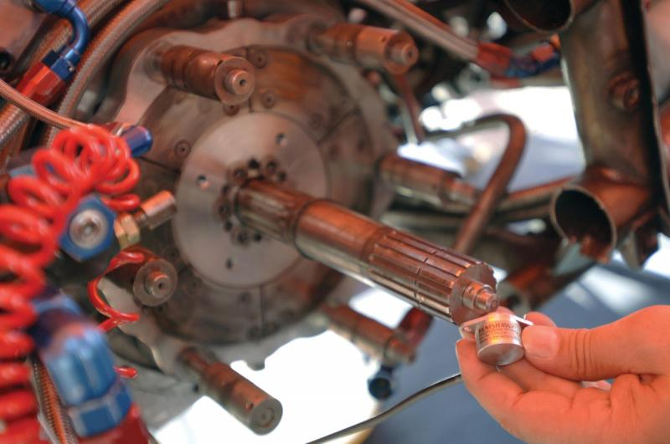This magnetic wheel mounts directly on the end of the shaft of this Salakazi drag motorcycle, while the encoder body is located in the clutch housing. The encoder withstands extreme acceleration and heat as the 1,500-hp cycle races beyond 300 km/hr in under 7 sec; it provides by-wire feedback for wheel speed, steering, and gearbox applications. Photo courtesy Renishaw.

One channel of a magnetoresistive sensor consists of two strips displaced one-half pole pitch from each other. They are connected differentially to double the sensor's output voltage. As the encoder wheel rotates past one pole (two sensor strips), the output voltage completes one cycle, generating a 40-mV peak-to-peak signal from a 5-Vdc power supply.

### **Encoder bearings and mounting options**

Most (though certainly not all) optical and magnetic encoders are supported by bearings that allow the shaft to turn while permitting the encoder housing (often enclosing sensor electronics and in some cases, code disc or wheel) to remain immobile. These bearings are not designed to support high loads, and should not be exposed to extreme shock, vibration, full system load, or that arising from misalignment. The relationship between bearing loading and life is:

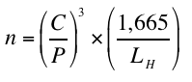

Where n = Bearing life, revolutions • C = Dynamic capacity (from manufacturer’s data) • P = Bearing load, lb • LH = Design life of bearing, hours. Bearing life is approximately inversely proportional to the third power of the load. Bearing assemblies can be built with tolerances that allow their use at higher speeds, to 30,000 rpm. However, if the encoder is hard-mounted to the motor shaft and the encoder housing is hard-mounted to a base plate, the bearing assemblies could experience side loads of several hundred pounds.

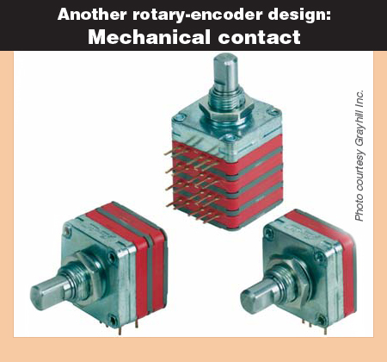Mechanical contact encoders utilize copper pads etched onto a circuit board (to encode position information) and brushes that ride over its conductive (and nonconductive) areas. Though not discussed in depth in this Study Guide, mechanical encoders are suitable for slow-moving applications or angular detection at startup.

Standard encoders incorporate their own shaft and bearing assembly. In very low-cost or miniature encoders, sometimes adhesive secures bearings to the shaft hub, though vibration can cause failure here. More commonly, the encoder shaft couples to the motor shaft with a belt, gear train, or coupling. For the latter, perfect alignment of encoder and driving shaft centers of rotation is impossible, so flexible couplings are often used. Manufacturers offer detailed guidelines on proper mounting.

In contrast, hollow-bore (also called hollow-shaft) encoders slide over and clamp onto a precision shaft, attaching directly to the motor frame through a flexible mount. A proper fit between the bore and shaft plus a good flex mount help retain accuracy and extend encoder bearing life.

Both standard and hollow-shaft encoders are known for being rugged.

The terms modular and kit in reference to rotary encoders mean different things depending on the manufacturer, but in both, locking fittings fix the disc or wheel to the shaft. Sensitivity to motor shaft run-out and axial movement can be issues, and on optical encoders, significant play can push the disc into the optics. Other modular encoders are fully contained, self-protecting shielded kits that mount to motor shafts.

In recent years, many manufacturers have increased the sizes of their encoder bearings, to carry more load and last longer. In certain cases, such bearings are fitted on opposite sides of a solid housing surrounding sensor electronics to make for a slightly bulkier design, but one exhibiting a durable shaft preload condition that can withstand significant radial and axial loads, shocks to 500 g, and -40 to +100° C.

Elsewhere, ceramic ball bearings (for isolation between the housing and encoder shaft) prevent shaft-current buildup from ac motors and generators — of particular concern on VFD-driven designs. Otherwise, unblocked stray or parasitic shaft currents through an earthed encoder housing to the ground cause electrical discharge machining (and failure) of bearing rollers and races.

Note that even ABEC 7 bearings have rolling errors of 22 arc-sec or so. Encoder resolutions exceeding 50,000 counts per turn reflect this bearing noise in the form of position error. Thermal mismatches between mating components in the bearing assembly can also degrade performance and expected life.

Die-cast housings on certain heavy-duty encoders allows the length of the shaft to be extended between bearings, allowing the mounting of a second encoder or mechanical centrifugal switch. This device triggers an action when a specific speed limit is exceeded; electronically independent of the first system, it provides redundancy in applications requiring extreme safety.

Note that if the encoder protrudes into a high-traffic area it may be subject to damage, such as from a hammer or forklift vehicle; if situated near floor level, an encoder can be perceived as a useful step. Here, a cage or shield may provide acceptable protection.

### **Encoder sealing and environmental protection**

For designs that incorporate bearings, perfectly sealed encoders are impossible, as there must be clearance to allow the bearing to slide over the shaft during encoder assembly. Even high-IP-rated bearings with rubber or plastic lip seals cannot cover all rotational speeds, designs, and mounting positions — and all seals are subject to wear, aging, and UV radiation degradation.

### Running at speeds up to 30,000 rpm with nearly zero wear, heavy-duty encoders monitor speed and position in harsh applications â€” for wind energy, steel processing, heavy industrial equipment, heavy duty vehicles, oil and gas processing, printing equipment, metal stamping and die casting, and motor and drive control.**Running at speeds up to 30,000 rpm with nearly zero wear, heavy-duty encoders monitor speed and position in harsh applications â€” for wind energy, steel processing, heavy industrial equipment, heavy duty vehicles, oil and gas processing, printing equipment, metal stamping and die casting, and motor and drive control.**

Encoder bearings can be open (least protection), shielded (moderate protection) or sealed (most protection). With all but totally sealed encoders (often associated with magnetic types) shaft-up encoder orientation is least preferred. That said, some hermetically sealed encoders (to IP67) can be installed in various directions, indefinitely submerged in liquids, or pressure washed to 12 bars and 100 liters/min. Labyrinth seals with reverse-lead spiral grooves prevent the ingress of liquids and particulates into the housing. However, shaft seals can be a source of heat generation, so designers must verify limits with the manufacturer.

### **Final notes on resolution and accurate output**

When specifying encoder resolution, error analysis is a consideration. It’s good practice to choose an encoder that will read two to four times better resolution than the machinery’s maximum error source. Resolution and bandwidth are related:

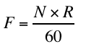

Where F = Frequency, Hz • N = speed, rpm • R = Resolution, counts per turn. System operating speed is usually known or dictated by tradeoffs such as system throughput versus scrap rates. Inherent errors in a system will limit resolution.

Using charts or manufacturer input, engineers can determine the operating bandwidth of the system. It’s dictated by the type of output driver (line driver, open collector, or push-pull hybrid), cable length and type, and controller-end terminations.

Consisting of two transistors with collectors connected, line drivers ensure low-impedance output. Because of their low impedance, they exhibit good noise immunity and can be used with cable lengths to 1,000 ft and operating frequencies to 1 MHz. However, their high switching speeds makes for ringing. Signals for these outputs should be specified to include the channel complements and be carried in shielded, twisted pairs — and fed to a high impedance differential-line receiver, or opto-isolator, which offers common mode noise rejection.

Due to their higher impedance, open collectors are more bandwidth limited. A good rule of thumb is to use them at a maximum of 50 kHz with a maximum of 50 ft of cable. They are the least expensive type of output. Note that the pull-up resistors can be user supplied or factory installed within the encoder, or both. The arrangement is often dictated by the controller or the need to operate the encoder at a different voltage than the supply voltage.

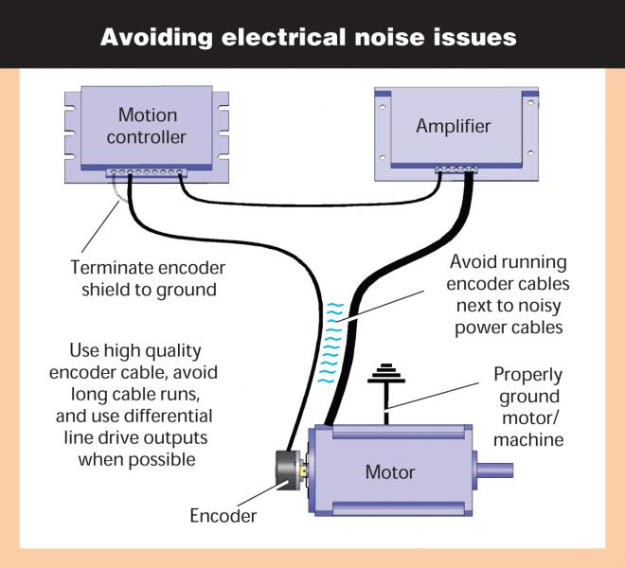Higher resolution doesn’t necessarily translate into higher system accuracy, but resolution that’s too low may limit the system's ability to control speed or position accurately. As implied earlier, incremental encoders with quadrature phasing not only provide directional information, but can increase resolution up to four times when combined with a compatible receiving device.

Encoder output data is sent to the controller via parallel binary, analog voltage or current, Profinet, Ethernet Powerlink, EtherNet/IP, Modbus, DeviceNet, Profibus, CANopen, or other networks. For example, Standard Serial Output (SSO) is typically leveraged in magnetic-encoder designs, allowing continuous synchronization during data transmission.

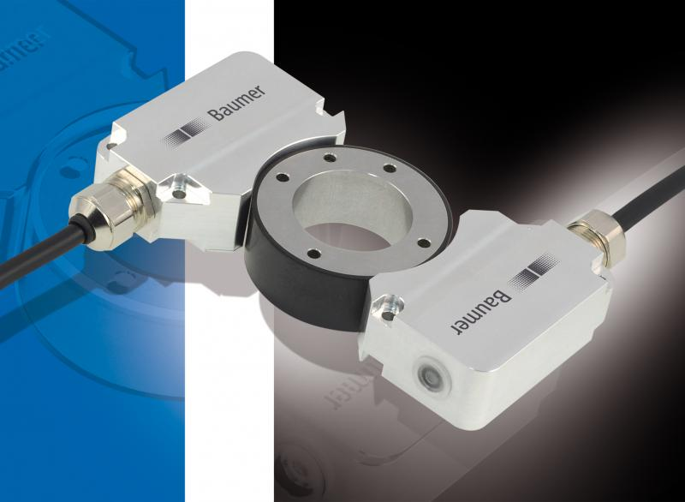This bearingless magnetic encoder offers reliable position values thanks to integrated sine-cosine monitoring for sensor signals. Its attachment style means that the shaft end remains free for other purposes. Position is output as absolute value with 16-bit resolution, optionally via SSI or CANopen interface. In the unit shown here, an additional incremental signal provides speed feedback (1,024 to 8,192 steps per turn.) Photo courtesy Baumer.

Another option is the Synchronous Serial Interface (SSI), a digital point-to-point interface. Common in Europe, it provides unidirectional communication to 1.5-MHz speeds and uses a six-wire cable — two carrying clock data to the encoder, two carrying data from it, and two wires for power. Finally, hardware compatible with SSI, connectable via a bus or point-to-point, Bidirectional Synchronous Serial interface (BiSS) is an open protocol that transmits encoder position data whenever the controller asks, allowing for quick recovery after interruptions. It also communicates encoder identification information, and acceleration, temperature, and other data without interfering with realtime operation.

**Note: A system’s controller generally dictates encoder output — so designers should first determine the controller's input requirements, and then select a compatible encoder output driver. The three basic types are drivers that supply current to external devices (sourcing); drivers that provide a current path to the circuit ground or common (sink); and drivers that do both (line drivers). Many controllers accept differential line-driver signals, canceling common-mode noise while accommodating long cable runs.**

To ensure reliability, the power supply to the encoder should be filtered and regulated; power lines for other devices should be routed away from encoder cabling. In some cases, specially coated terminal boxes shield against electromagnetic compatibility fields to prevent signal output failure. Encoders designed with such boxes can be rotated through 180° to position the cable opening to the left or the right of the encoder (to facilitate installation.) In all cases, shielded twisted pairs of cable are required, and the ground properly connected — preferably in star arrangement — to ensure effective shielding.